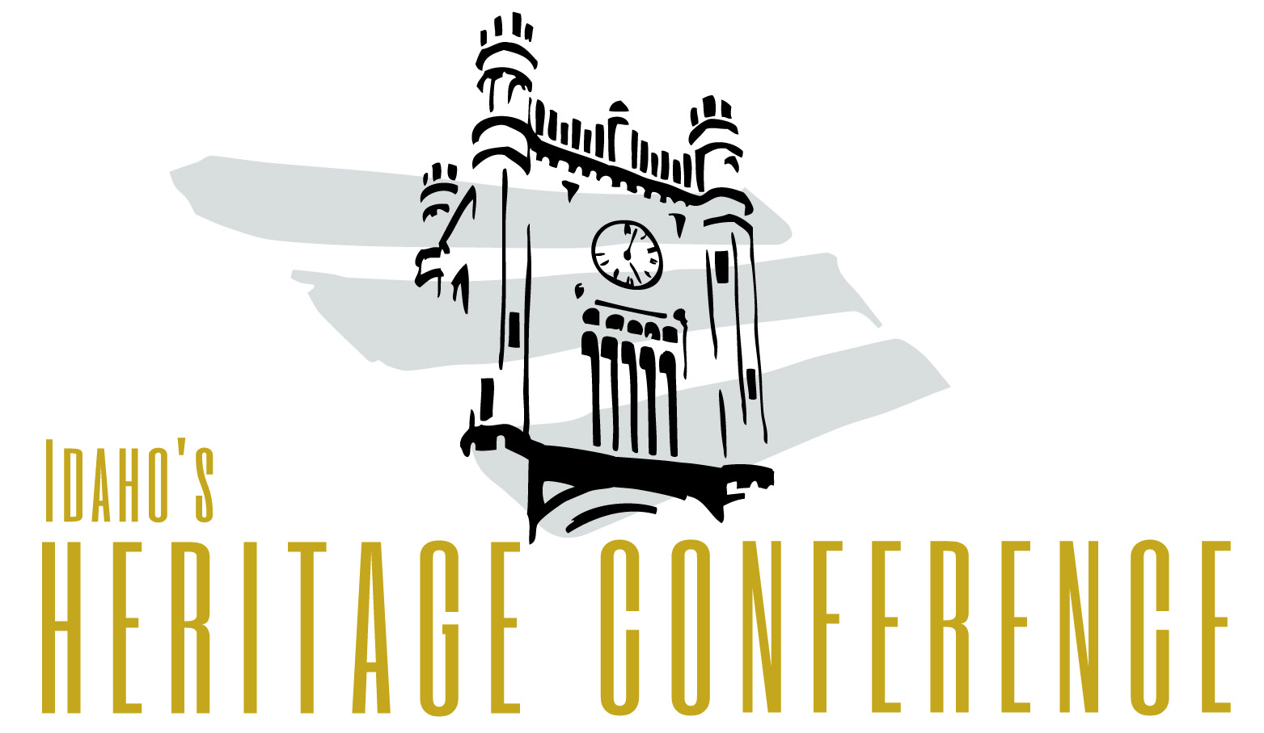
PRESS RELEASE
Contact: Katherine Kirk, Executive Director
Phone: (208) 549-1778
Email: katherine@idahoheritagetrust.org
Website: www.idahoheritage.org

Idaho’s Heritage Conference coming to Moscow in 2015

BOISE – Idaho’s Heritage Conference is coming to Moscow in autumn 2015.

The second biyearly conference, which features field sessions, educational classes, and cultural events, aims to promote the state of Idaho and ensure history survives for future generations. The first Idaho’s Heritage Conference was held in Boise in August 2013.

“There are so many possibilities for attendees to explore a rich heritage and diverse culture in the city of Moscow and surrounding areas,” said Idaho Heritage Trust Executive Director Katherine Kirk, who is one of the lead planners for Idaho’s Heritage Conference. “We were especially impressed that the City of Moscow was not only involving its historians, educators, and museum experts, as well as business leaders and economic development, as a key aspect of hosting the conference. “

Attendees will learn from regional and national experts in history, preservation, archaeology, cultural, resources and economic development. Local partners, including the City of Moscow, University of Idaho, Chamber of Commerce, Nez Perce and Coeur d’Alene Tribes, and the Latah County Historical Society, are signed on as partners to the conference, Kirk said.

Those local organizations will join the Heritage Partners, a coalition that includes the Idaho State Historical Society, Idaho Heritage Trust, Preservation Idaho, Idaho Archaeological Society, and the Idaho Association of Museums, to host the 2015 event.

More than 200 people attended the inaugural Idaho’s Heritage Trust, held in August 2013. Of those who responded to a feedback survey, 92 percent rated the conference as “Excellent” or “Very Good,” and 98 percent indicated they would like to see the conference continue as an ongoing event, Kirk said.

“There is great opportunity to learn from the heritage and history across Idaho,” Kirk said. “We want to ensure that attendees have the chance to learn and explore all the corners of our state.”

Idaho’s Heritage Conference is aimed at anyone interested in learning about or sharing their knowledge of the state of Idaho, from professional historians, archaeologists and teachers to students, community leaders and local history buffs. The conference aims to connect people, knowledge, and powerful ideas to build the story of Idaho’s diverse heritage.

###

